**COS30002**

**Lab Report – Task 5 (28/3/2021)**

Ryan Chessum 102564760

* Installed Pyglet
* Downloaded Planet Wars
* Familiarised myself with how Planet Wars works
* Created “Rando” the bot that makes random moves
* Learnt about Pythons Lambda function
* Created a bot that attacks the weakest planet
* Created a bot that attacks the strongest planet
* Created a bot that randomly picks the strongest or weakest planet to attack

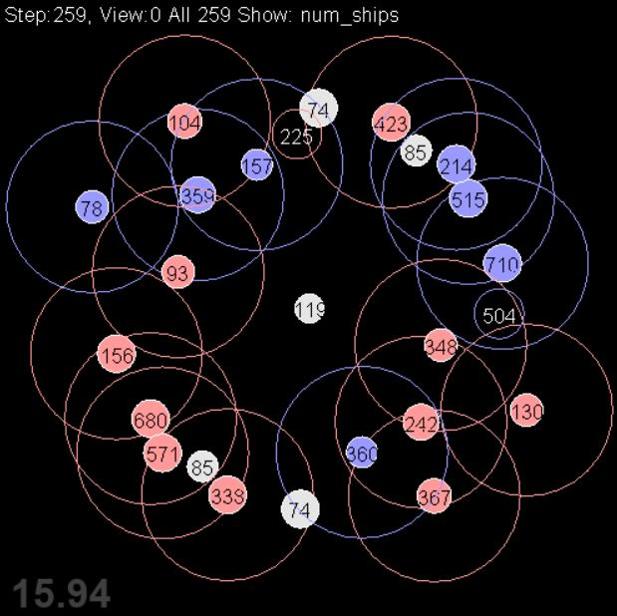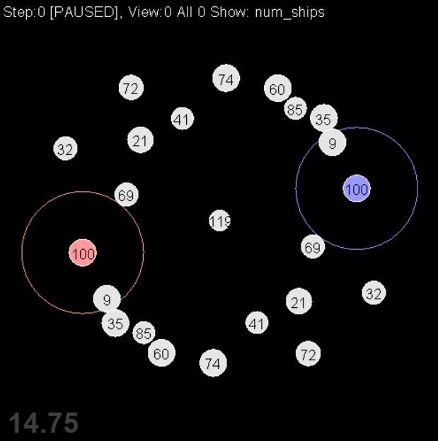

**Bot Code**

**Rando:**

from random import choice

class Rando(object):

    def update(self, gameinfo):

        pass

        # only send one fleet at a time

        if gameinfo.my_fleets:

            return

            # check if we should attack

        if gameinfo.my_planets and gameinfo.not_my_planets:

            # # select random target and destination

            dest = choice(list(gameinfo.not_my_planets.values()))

            src = choice(list(gameinfo.my_planets.values()))

                 # launch new fleet if there's enough ships

            if src.num_ships > 10:

                gameinfo.planet_order(src, dest, int(src.num_ships * 0.75) )

**Strategist:**

from random import choice, randint, randrange

class Strategist(object):

    def update(self, gameinfo):

        pass

        # only send one fleet at a time

        if gameinfo.my_fleets:

            return

            # check if we should attack

        if gameinfo.my_planets and gameinfo.not_my_planets:

            #target either the planet with the lowest or highest amount of ships

            strategy = randrange(2)

            if strategy == 0:

                dest = min(gameinfo.not_my_planets.values(), key=lambda p: p.num_ships)

            else:

                dest = max(gameinfo.not_my_planets.values(), key=lambda p: p.num_ships)

            src = choice(list(gameinfo.my_planets.values()))

                 # launch new fleet if there's enough ships

            if src.num_ships > 10:

                gameinfo.planet_order(src, dest, int(src.num_ships * 0.75) )